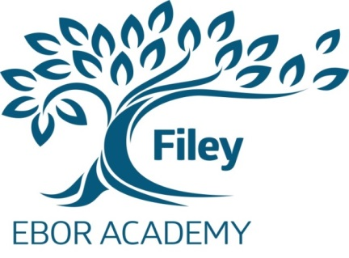
Ebor Academy Filey
Muston Road, Filey, North Yorkshire, YO14 0HG

Telephone: 01723 512 354
Fax: 01723 512 165

Email: admin@filey.n-yorks.sch.uk
Website: www.fileyschool.com

3rd February 2016

Dear Parent /Guardian,

Coach tour to London: 20th October – 22nd October 2016

Ebor Academy Filey is keen to offer our students the opportunity to experience a range of diverse and interesting educational experiences during their time here. As part of this expanding programme, we are now in the process of arranging another tour to London in October for Year 10 and 11 only. There are only 35 places available on the tour. It will be accompanied by four staff.

This is an extended visit taking place over three days and includes the following:
- Travel Insurance
- Two nights accommodation, at a hotel located near to a significant landmark, in shared en-suite rooms
- Two West End Theatre Shows
- 2 Course Meal with Soft Drink & Dessert at Pizza Express
- 2 Course Meal with Soft Drink at Restaurant (Set Menu)
- Shakespeare's Globe including Tour, Exhibition and 90 minute Workshop
- Warner Bros ‘Harry Potter’ Studio Tour
- 90 Minute West End Workshop - Tailored to Show
- Opportunity to visit Natural History Museum/Covent Garden area
- Tour cost: £380 per person

Tour arrangements have been organised through NST. This provider offers tours which are tailor-made to support groups in getting the very most out of their time away. Safety, value and ease are at the heart of every NST educational school visit and study tour. They have been a leading provider of school trips since 1967. They take over 100,000 children away each year.
We expect there will be a high level of interest in this visit. So early booking is recommended. It is possible to use Parentpay to both give consent and pay the deposit. Alternatively, please complete the slip overleaf and return it together with the initial deposit of £80.00 to ‘Ebor Academy Filey ‘ by February 10th. Further instalment of £50 per month will be required until the end of the school year (July 19th) Please make cheques payable to the school.
Yours sincerely,

Julia Waines
Assistant Principal

STUDENT NAME: _________________________ ________________ TUTOR GROUP__________

I would like my son/daughter to visit London in October 2016.
I enclose a deposit payment of £80.00 for the trip/I have used Parentpay for the £80.00 deposit

Signed…………………………………………………………………………………………………………… Parent/Carer

