HEADTEACHER’S NEWSLETTER

Friday 15th April 2016

Dear Parent/Carer

Welcome back to our Summer term, this is a very busy time of year for
all of us as Yr11 students prepare for final GCSE examinations and we
continue to prepare for the arrival of new students in the next academic year. This week we have a new feature in the newsletter “Student in the Spotlight”. This will allow us to showcase student’s achievements outside of school and to celebrate their dedication to their interests and hobbies. If you would like to see your son or daughter featured, please contact Mrs Hinchliffe at school.

We are continuing to develop ways in which we communicate with parents, I appreciate not everyone uses social media as a rule. If this is the case, please do contact us by telephone or call in to school to discuss ways in which you feel we may be able to develop this area.

Duke of Edinburgh Award Scheme
Whilst the majority of us were relaxing over the Easter weekend a group of intrepid adventurers set out on a voyage of discovery, undertaking their D of E Bronze practice walk in the Howardian Hills. Ably assisted by three student volunteers the expeditioners practiced their map and compass/campcraft skills; including self- reliance and resilience and all managed to complete a very successful weekend. They continued their voyage on 8th-10th April in Nidderdale based at Bewerley Park to undertake their expedition assessment. Aided by 2 student volunteers the expeditioners were tested on their ability to work as a team using their skills and all managed to complete this part of their assessment and now need to present their journals to complete the expedition section of this most prestigious award. Congratulations to Millie Moore, Alex Rodgers, Jon Hanson, Declan Cornwall, Ewan Newby, Cameron Cole, Oliver Turner, Hollie Button, Daniel Baxter, Evie White, Liam Prescott & Tommy Furness. Thank you to the following student helpers and staff for giving up their weekends: James Bowes, Jayne Courtland, Emily Hinchliffe, Mr Chalk, Miss Francis & Mr Moore. A further 6 students will be undertaking their assessment in May.

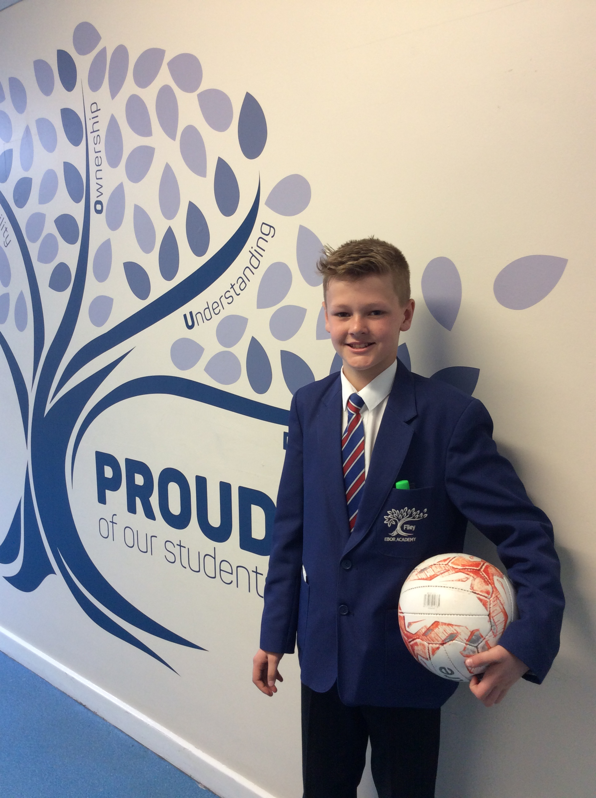
NEW FEATURE – “Student in the Spotlight”
Thomas Macauley (Yr7) is part of Hull City FC’s under 12’s Academy squad and a member of their “Elite Player Performance Plan”. Before moving to the Filey area Thomas was part of Tottenham Hotspurs U9’s and U10’s Academy squads. Thomas is a very promising goalkeeper who enjoys playing outfield for the school football team as to quote “it helps to develop my footwork”. Later this year Thomas will represent Hull City FC in the International Football Festival in Holland, playing against teams such as Real Madrid and AC Milan. His favourite footballer is Manuel Neuer, the Bayern Munich and German national team Goalkeeper, who is a pretty good role model for any young aspiring goalkeeper. You may want to remember Thomas’ name as he is a star to look out for in the future.

Ski Trip
Travelling with 40 teenagers for 25 hours across Europe, on a coach, may not be everyone’s idea of a good time…but these were no ordinary teenagers! They were Ebor Academy students! As such, the whole experience of taking them to ski in Austria during the Easter holidays was a real privilege. Staff who accompanied the trip were delighted with the progress of all the students who went and compliments
were received from the director of the company, who provide the instructors and equipment, on the way

the students were learning so rapidly. By the end of the second day all the beginners
were ready to attempt the more challenging slopes, where the experienced skiers had been
since day one. Their improvement was seen very clearly when the assessments for GCSE PE
were done at the end of the week.
We will be announcing the dates and cost of next year’s ski trip very soon!

Charity Football Day
Saturday 23rd April 10am-4pm at Hunmanby Sports Club. There will be various stalls including ferret racing, shabby chic, face painting, bouncy castle and much more. Stalls can be purchased for £15, if you are interested please email Geo.White@hotmail.co.uk All proceeds to go to the M10 Missions, the charity which sends young people over to Mexico to build houses for the less fortunate families living in the slums.
Further fundraising initiatives which are planned for this cause are:-
Monday 2nd May – Bag Pack, Tesco Filey
Saturday 7th May – Bag Pack, Morrisons Scarborough

Festival of Filey – Coffee Morning & Festival Concert
As part of the Festival of Filey we are delighted to be hosting a coffee morning with a choir performance 9.30-11am on Thursday 30th June. Followed in the evening by the Festival Concert starting at 7pm. Look out for further details soon.

Filey Town Council – Cheque Presentation
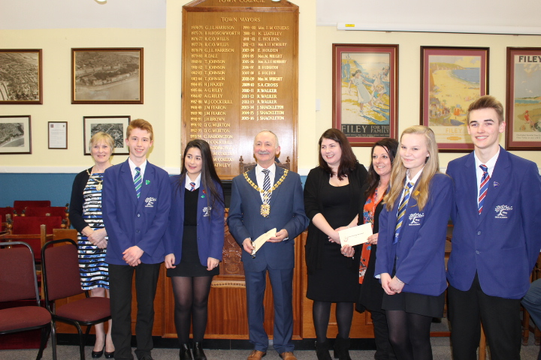
A group of Yr11 students recently applied for a grant from Filey Bay Today to enhance their common room area, locally known as “The Bistro”. Recently they have received donations of soft furnishings and leather sofas and this successful bid was for a “Memory Board”. The students are photographed here receiving a cheque for £80 from the Mayor and Mayoress of Filey at the Town Council Chambers. Mrs Ingham who supported the students with the bid is also pictured.

Sports Facilities
We are currently looking to improve our sports provision and would like to be able to make new facilities available to the local community. In order to get the best quality provision we are looking to secure some funding from Sport England. For this we need to evidence a community demand. Are you involved in a club or community group who could benefit from a 3G 5-a-side pitch and/or an astro-turf pitch? If so please contact us to express your interest, no later than 27th April.

Congratulations!
Students of the Month – March
Owain Barnett, Dylan Daniels, Tom Garside, Matthew White, Grace Miller, Casey Lawrence, Amelia Rudeforth, James Carroll, Hannah Wheatley, Ellery Liley, Becky Brown, Dean Sutton, Abi Hewitson, Mathew Stephenson, Daniel Payne, Jack Bennett & Jasmine Rhodes
Students of the Week Year 7 Year 8
17th March Chloe Roberts, Dylan Barnett Abbie Lee, Ryan Bailey
15th April Lilly Tyson, Joseph Harrison Emily Pooley, James Stacey

Mr Galbraith
Headteacher

@ebor_filey facebook.com/Ebor-Academy-Filey www.filey.ebor.academy

