HEADTEACHER’S NEWSLETTER

Our students are now into the full swing of this academic year,
thank you for working with us on issues such as attendance, behaviour,
uniform and high expectations. I feel it is really important for us to maintain
that team approach and I know as a parent it can be challenging dealing
with teenagers, I have over 300 at work too!

We realised this week an unusual occurrence in Yr7, we have four sets of twins; three of them identical have joined us in Year 7 this year. We have twins elsewhere in the school, but out of an intake of 86, in a single year, this is quite unusual.

Never one to miss a photo opportunity, I caught up with all of the twins this week to capture the moment we had them all together.
From left, Ben and James Scaife, Casey and Ebony Crabtree, Beth and Nicole Barnes and James and Matthew Walker.

MacMillan Coffee Morning
You are invited to join us to ‘Change Lives with every Slice’ at our MacMillan Coffee Morning on Friday 30th September 9.45 – 11.15am in the school hall. Donations of cakes and raffle / tombola prizes would be very gratefully received. Last year’s event was an enormous success and thanks to the generous support of parent, carers, friends and family we raised over £500.

National School Equestrian Association
Ebor Academy are now members of the ‘National School Equestrian Association’ and we invite all those who would be interested in representing the school to get in touch with Liz Barnes, email lizbarnes82@btinternet.com
There are many different riding disciplines and levels open to those who have their own horse. For further information about the events please have a look on the website www.nsea.org.uk

Diary Dates:
Friday 30th September: MacMillan Coffee Morning
Tuesday 11th October – Open Evening for prospective parents and students in Years 5 & 6
Monday 17th October – Student Council London visit for Tour of Parliament.
Thursday 20th – Saturday 22nd October – Year 10 London Theatre Trip
Monday 24th – Friday 28th October – Autumn Half Term Holiday
Monday 31st October – Return to School
Key dates are listed on the inside front cover of the student planner. Please note a change to the Year 9 Parents Evening which will now be held on Wednesday 8th March 2017.

Attendance
Our School target is 100%. Regular attendance at school is vital to help children achieve and get the best possible start in life. Children who frequently miss school often fall behind. There is a strong link between good school attendance and achieving good results. For example, only 12% of students with below 80% school attendance achieve five or more GCSEs at grades A*-C including English and Maths, compared to 68% for pupils with attendance greater than 95%.

I have asked the school attendance team to initiate home visits from Friday 30th September;
this happens even if your child is reported ill so we can see how to best support you with any
learning that may be missed due to absence. Please contact us at the earliest point of the known
absence so that we can support your child.

Parent Focus Group
I met this week with members of “The Parent Focus Group”. We discussed issues and concerns raised by parents and carers which they will feedback through the PFG Facebook page. We also discussed how we could attract new members and look at ways of turning the group into a positive means of fundraising between parents, students, staff and local businesses. The group will be hosting a drop-in session in November. Watch this space for further details.
If you are interested in joining the group, please contact Mrs Hinchliffe (Headteacher’s PA) at the school.

News from the PE Department
Well done to Year 10 Netball girls who played Malton in the Knock Out Cup game on 14th September. They put up a good fight but in the end Malton won taking them through to the next round, but not a bad game to start the season, the girls played really well.
Well done to all the Y7 boys who were selected for the U12 District Football trials on Wednesday. The standard was exceptionally high and all of the boys did extremely well. Congratulations to Max Aitken who made it through to the second round.
Well done to everyone who took part in the Y7 House Matball Tournament last week. It was a fantastic event with lots of enthusiasm and competitive spirit.
Positions are as follows. 1st Carr, 2nd Wold, 3rd Glen, 4th Brigg.

Scarborough RUFC Junior Rugby
The Scarborough U12s (Year7) are looking for new players to join their small and friendly team. Anyone interested should contact the team coach, Alex Sharp, on 07810 823727.

Congratulations!
Students of the Week
16th September Ellie Carter, Max Aitken, Shakira Day, Cameron Lester
23rd September Max Short, Caitlyn Murray-Rae

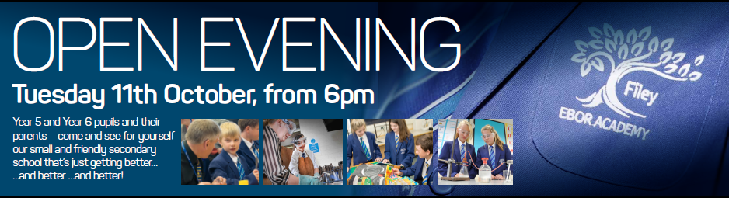

Yours sincerely

Mr Galbraith
Headteacher
@ebor_filey facebook.com/Ebor-Academy-Filey www.filey.ebor.academy

