27th November 2017

Dear Parents / Carers

This term ends on Friday 22nd December 2017 at the earlier time of 12.30pm. School transport has been arranged for this earlier time. Students return to school on Monday 8th January 2018.

Our Christmas Concert is on Tuesday 19th December at 7.00 pm. Seats are allocated on a first come first served basis and initially will be limited to 2 per student. Tickets are £2 for adults and £1 for concessions, which includes mulled wine or a soft drink and a mince-pie. To reserve please return the attached slip or contact Mrs Mathewson in the school office.

I look forward to celebrating Christmas with you.

Yours sincerely
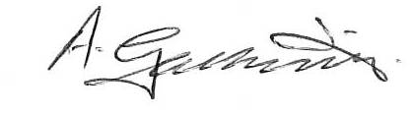

Mr A Galbraith
Headteacher
………………………………………………………………………………………………………

Ebor Academy Filey – Christmas Concert – Tuesday 19th December 2017

Name: ...................................................... (Please print) Contact Tel. No. (Daytime)...............................

Number of seats required: ……………………………………………………………………

(Please note that names are not put on seats. This is purely to ensure we put the correct number of seats out in the Hall. It also gives us an idea of the numbers we are catering for with refreshments).

Signed: ………………………………………….………… Date: ………………………………………

Please return the reply slip to school by Thursday 14th December 2017.

